October 15th, 2006
Hi,
Very, very little to write about.
I have been extremely busy this past week proof-reading Singapore chemistry books after they have been printed as there are still glaring errors in it. The problems all go back to the Singapore Ministry if Education who returned the submitted copies that had to be vetted several months late. As that left the publisher very little time to get everything done before the launch last August, the editors, unfortunately, had to be given some latitude to make changes/corrections especially as the textbook was over the page limit allowed. However, they did not also do a good job as I discovered while preparing the teachers’ book using the textbook. Even without reading every word, I was finding errors everywhere. So, I decided that the whole book needed to be proofread again. The publisher will stick an errata sheet in the books for major errors; however I do not like this as it makes clear to everybody that there are errors in the books!
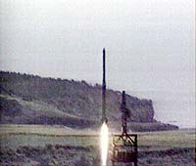
The big news of the week I suppose was the apparent explosion of an underground atomic bomb by North Korea. There is doubt in some circles that the test was successful. I think that part of the problem is due to the US which keeps pushing North Korea into a corner, and as everybody knows that people in this situation tend to fight back. I think the same thing is going to happen in Iran, as it is beginning to happen in Palestine.
This past week, I only went for one swim, and ended up doing 3 km having originally thought of doing only 1 km. Did the swim instead of a session of rowing. Also did two 30-minute runs, both at 12 km/h (= 7.5 mph); I am not yet able to get to the 8 mph I was doing a couple of years ago. Only another month and it will be the running/hiking season again.
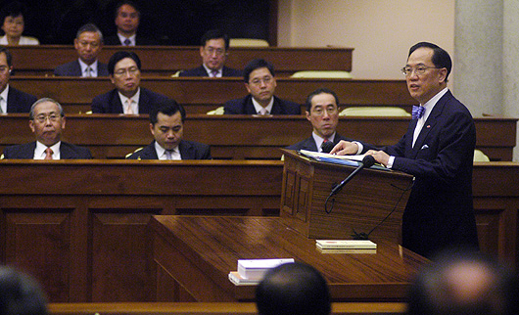
The other day, three large pipes fell (each about 30 feet in length) about 30 floors from a construction-site crane onto a main road on HK Island. Fortunately, no-one was killed but a car was flattened when one pipe landed on it; the driver had a lucky escape. The Chief executive gave his annual speech (see picture); I have forgotten what it is called but I guess it is something like the US ‘State of the Union’ address. (Have just discovered that it is called a ‘Policy Address.’) He mainly talked about things that the next Chief Executive (who will probably be he himself), who will be chosen in about 8 months, will need to consider. Interestingly, there was no mention at all about the introduction of GST, which the government has been pushing hard but getting nowhere with almost everybody is against it. The only other HK bit of news is about restaurants. We often hear about restaurant closures (and owners not having paid employees for months). Well, this morning, while on my way to the supermarket, I discovered that the restaurant on the first floor of this building has closed down.
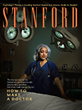
Yesterday, I received a Stanford alumni magazine. This is the first time I have received it, as limited funds in the past meant that not everyone could get it, and I suppose that included all overseas alumni. One of the main articles talks about the medical school and how it is introducing students to patients in their first year. Leonie, if you are interested in what they are doing, go to this website:
http://www.stanfordalumni.org/news/magazine/2006/sepoct/features/doctor.html
That’s about it for now.
Cheers.

